📘 Pandemic Patterns: Unveiling COVID-19 Dynamics in India Through Excel Dashboard Analytics

Cover Page
Project Title: Pandemic Patterns: Unveiling COVID-19 Dynamics in India Through Excel Dashboard Analytics
Name: SARATHRAJ R
Batch: DS ProX56
Course: Excel Analytics
Dataset Name:
- covid_19_india.csv
- covid_vaccine_statewise.csv
- StatewiseTestingDetails.csv

Section 1: Project Overview & Objectives

Project Overview
The COVID-19 pandemic significantly impacted India, presenting complex challenges across healthcare, governance, and public awareness. Large volumes of data were generated daily, including confirmed cases, recoveries, deaths, testing figures, and vaccination progress across states and union territories.
This project focuses on transforming raw COVID-19 datasets into meaningful insights using SQL for data processing and Excel for analysis and dashboard visualization. The aim is to provide a clear understanding of pandemic trends and state-wise impacts through interactive analytics.

Project Objectives
- To clean and transform raw COVID-19 data using SQL (ETL process)
- To analyze case trends, testing efficiency, and vaccination progress using Excel
- To build an interactive Excel dashboard for visual storytelling
- To identify key insights and actionable recommendations based on data
- To enhance analytical, visualization, and reporting skills

Section 2: ETL PHASE(SQL)
CREATE TABLE covid_cases (
sno INT,
date TEXT,
time TEXT,
state_union_territory VARCHAR(150),
confirmed_indian_national TEXT,
confirmed_foreign_national TEXT,
cured INT,
deaths INT,
confirmed INT
);

CREATE TABLE covid_testing (
date TEXT,
state VARCHAR(150),
totalsamples TEXT,
negative TEXT,
positive TEXT
);

CREATE TABLE covid_vaccine_statewise (
updated_on DATE,
state VARCHAR(100),
total_doses_administered NUMERIC,
sessions NUMERIC,
sites NUMERIC,
first_dose_administered NUMERIC,
second_dose_administered NUMERIC,
male_doses_administered NUMERIC,
female_doses_administered NUMERIC,
transgender_doses_administered NUMERIC,
covaxin_doses_administered NUMERIC,
covishield_doses_administered NUMERIC,
sputnik_v_doses_administered NUMERIC,
aefi NUMERIC,
age_18_44_doses_administered NUMERIC,
age_45_60_doses_administered NUMERIC,
age_60_plus_doses_administered NUMERIC,
age_18_44_individuals_vaccinated NUMERIC,
age_45_60_individuals_vaccinated NUMERIC,
age_60_plus_individuals_vaccinated NUMERIC,
male_individuals_vaccinated NUMERIC,
female_individuals_vaccinated NUMERIC,
transgender_individuals_vaccinated NUMERIC,
total_individuals_vaccinated NUMERIC
);

-- SECTION 2 — LOAD DATA

-- Loaded using Import data in the created table
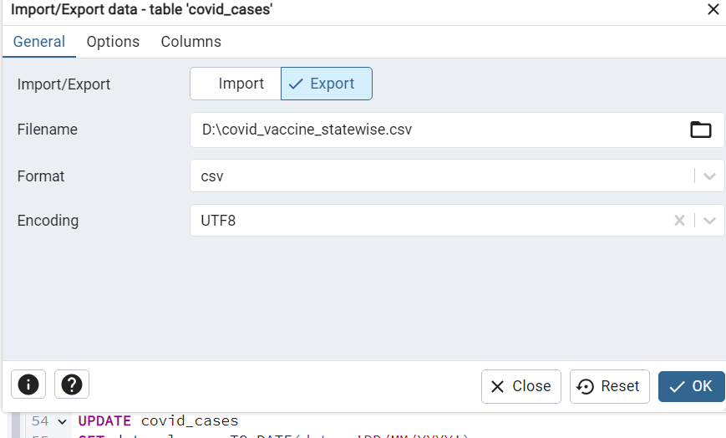

-- SECTION 3 — sample of 10 rows

SELECT COUNT(*) FROM covid_cases;
SELECT COUNT(*) FROM covid_testing;
SELECT COUNT(*) FROM covid_vaccine_statewise;

SAMPLE DATA

SELECT * FROM covid_cases LIMIT 10;
SELECT * FROM covid_testing LIMIT 10;
SELECT * FROM covid_vaccine_statewise LIMIT 10;
— SECTION 4 — Distinct States

SELECT DISTINCT state_union_territory FROM covid_cases;
SELECT DISTINCT state FROM covid_testing;
SELECT DISTINCT state FROM covid_vaccine_statewise;

— SECTION 5 - CHECK MISSING VALUES
SELECT * FROM covid_cases
WHERE confirmed IS NULL OR deaths IS NULL;

SELECT * FROM covid_testing
WHERE totalsamples IS NULL OR positive IS NULL;

SELECT * FROM covid_vaccine_statewise
WHERE first_dose_administered IS NULL;
SECTION B — TRANSFORM (Clean & Engineer Data)
Standardize all date formats
ALTER TABLE covid_testing ADD COLUMN date_clean DATE;

UPDATE covid_testing
SET date_clean = date::DATE;

ALTER TABLE covid_cases ADD COLUMN date_clean DATE;

UPDATE covid_cases
SET date_clean = date::DATE;
Vaccination table I have included the same data type while Importing the csv.

CLEAN NUMERIC VALUES
UPDATE covid_testing
SET totalsamples = NULLIF(totalsamples,''),
positive = NULLIF(positive,'');

ALTER TABLE covid_testing
ADD COLUMN totalsamples_clean BIGINT,
ADD COLUMN positive_clean BIGINT;

UPDATE covid_testing
SET
totalsamples_clean = totalsamples::FLOAT::BIGINT,
positive_clean = positive::FLOAT::BIGINT;

— DAILY NEW CASES
ALTER TABLE covid_cases ADD COLUMN daily_new_cases BIGINT;

UPDATE covid_cases c
SET daily_new_cases = sub.new_cases
FROM (
SELECT
state_union_territory,
date_clean,
confirmed - LAG(confirmed)
OVER (PARTITION BY state_union_territory ORDER BY date_clean)
AS new_cases
FROM covid_cases
) sub
WHERE c.state_union_territory = sub.state_union_territory
AND c.date_clean = sub.date_clean;

— TOTAL CONFIRMED

UPDATE covid_cases
SET total_confirmed =
COALESCE(NULLIF(NULLIF(confirmed_indian_national,'-'), '')::BIGINT, 0) +
COALESCE(NULLIF(NULLIF(confirmed_foreign_national,'-'), '')::BIGINT, 0);

— CASE FATALITY RATE

ALTER TABLE covid_cases ADD COLUMN cfr FLOAT;

UPDATE covid_cases
SET cfr = (deaths::FLOAT / NULLIF(confirmed,0)) * 100;

—- -- JOIN CASES + TESTING

SELECT
c.state_union_territory,
c.date_clean,
c.confirmed,
t.totalsamples_clean,
t.positive_clean
FROM covid_cases c
JOIN covid_testing t
ON c.state_union_territory = t.state
AND c.date_clean = t.date_clean
LIMIT 10;

—- SECTION C LOADING FINAL DATASET (COVID SUMMARY)
DROP TABLE IF EXISTS covid_summary;

CREATE TABLE covid_summary AS

SELECT
c.state_union_territory AS state,
c.date_clean AS date,

c.confirmed,
c.deaths,
c.cured,

c.daily_new_cases,

t.totalsamples_clean AS total_samples,
t.positive_clean AS positive,

v.first_dose_administered,
v.second_dose_administered,

-- CFR
(c.deaths::FLOAT / NULLIF(c.confirmed,0)) * 100 AS cfr,

-- Positive Test Rate
(t.positive_clean::FLOAT / NULLIF(t.totalsamples_clean,0)) * 100 AS positive_test_rate

FROM covid_cases c

LEFT JOIN covid_testing t
ON c.state_union_territory = t.state
AND c.date_clean = t.date_clean

LEFT JOIN covid_vaccine_statewise v
ON c.state_union_territory = v.state
AND c.date_clean = v.updated_on;

— ADDDING RISK LEVEL
ALTER TABLE covid_summary ADD COLUMN risk_level VARCHAR(20);

UPDATE covid_summary
SET risk_level =
CASE
WHEN cfr > 2 AND positive_test_rate > 10 THEN 'High Risk'
WHEN cfr > 2 OR positive_test_rate > 10 THEN 'Medium Risk'
ELSE 'Low Risk'
END;

SQL LINK -

Section 3: Excel Analysis
Summary_final_covid_table_cleaned 1.xlsx

Missing Data Handling

🔹 Approach
The dataset was first inspected for missing or inconsistent values in key columns such as:
- totalsamples
positivehttps://docs.google.com/document/d/1C0L4usDQYfC-N7CPa2U17LRIbNh7FKnz3g-oaleIEME/edit?usp=sharing
- first_dose_administered

🔹 Approach
- second_dose_administered
Using:
=COUNTBLANK(G:G)
Additionally, filters were applied to identify empty or zero-value rows.

🔹 Cleaning Method
Since missing values were mostly from early pandemic stages (when testing/vaccination was not fully recorded), they were handled by:
- Replacing blanks with 0 using:
Find & Replace → Replace blank with 0

🔹 Observation
- Missing values were concentrated in early 2020
- Vaccination columns had more missing data compared to cases
- This reflects real-world delay in vaccination rollout

Normalize Date Formats
The date column had mixed formats. It was standardized to:
dd-mm-yyyy
Using:
=TEXT(B2,"dd-mm-yyyy")

🔹 Outcome
- Ensured consistency across dataset
- Enabled proper sorting and time-based analysis

Calculate Daily New Cases

🔹 Approach
Daily new cases were calculated using:
= C2 - C1
(Where column C = confirmed cases)

🔹 Logic
- Data was sorted by State + Date
- Difference between consecutive rows gives daily increase

🔹 Insight
- Sudden spikes were visible during wave periods
- Some negative/zero values indicated data corrections

Statewise Case Proportion

🔹 Approach
Step 1: Calculate total cases per state
=SUMIF(A:A, A2, C:C)
Step 2: Calculate proportion
= C2 / SUM(C:C)

🔹 Insight
- States like Maharashtra & Karnataka contributed major share
- Smaller regions had negligible proportions

Statewise Case Proportion

🔹 Approach
Step 1: Calculate total cases per state
=SUMIF(A:A, A2, C:C)
Step 2: Calculate proportion
= C2 / SUM(C:C)

🔹 Insight
- States like Maharashtra & Karnataka contributed major share
- Smaller regions had negligible proportions

Cumulative Vaccination Rate

🔹 Approach
Using latest available data:
= total_doses_administered / population
(Population approximated externally)

🔹 Insight
- Urban states showed higher vaccination rates
- Early data had very low coverage

Merge Case and Testing Data

🔹 Approach
Data already merged via SQL.
In Excel, validation was done using:
VLOOKUP (state + date)

🔹 Outcome
- Combined dataset enabled testing vs cases comparison
- Improved analytical depth

Positive Rate Calculation

🔹 Formula
= positive / totalsamples

🔹 Insight
- High positive rate indicates insufficient testing
- Some states showed >10% → high risk

Age Group Vaccination Analysis

🔹 Approach
Used vaccination dataset columns:
- 18–44
- 45–60
- 60+
Pivot Table:
- Rows → Age group
- Values → Sum of doses

Insight
- Highest vaccination observed in 18–44 age group
- Elderly vaccination slower initially

Top 5 Regions with Highest Cases

🔹 Approach
Sorted confirmed column in descending order

🔹 Insight
- Maharashtra, Karnataka, Tamil Nadu among top contributors

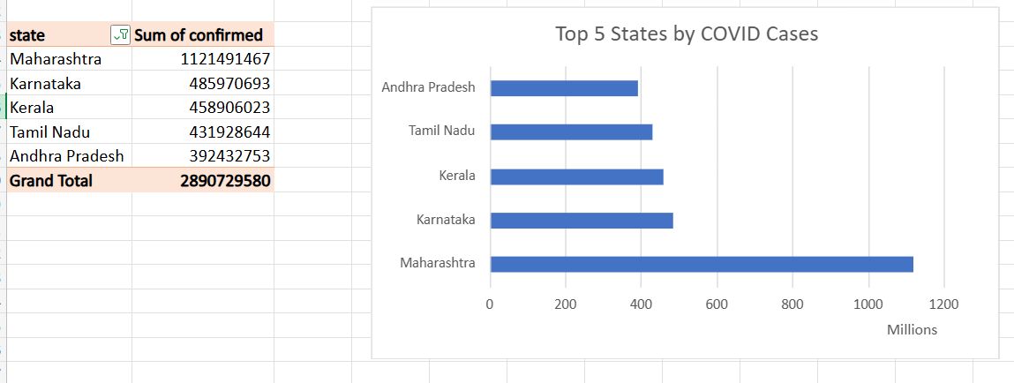

12 Month-wise Case Trend

🔹 Approach
Pivot Table:
- Rows → Month
- Values → Sum of confirmed

🔹 Visualization
📈 Line Chart

🔹 Insight
- Clear wave patterns observed
- Peaks aligned with known COVID waves
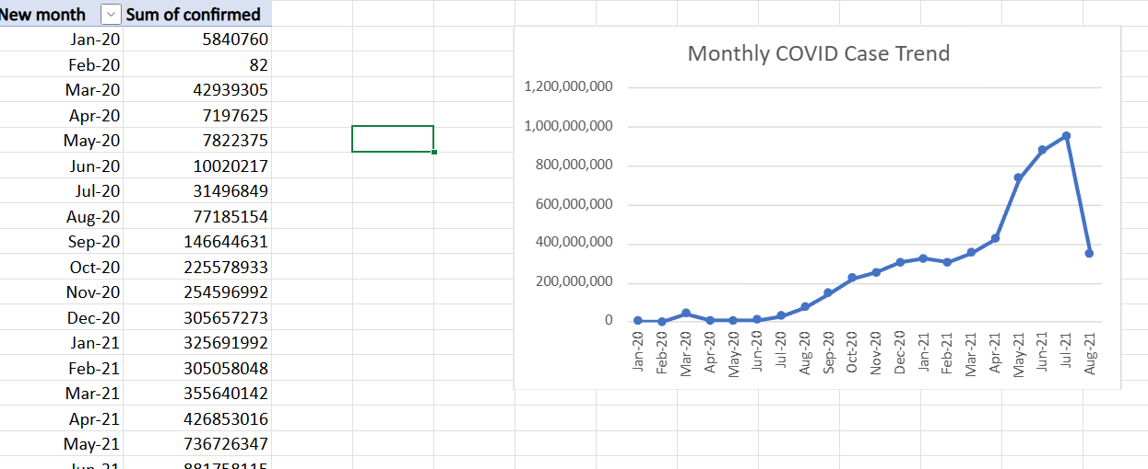

12 Weekday Analysis

🔹 Approach
=TEXT(B2,"dddd")
Pivot:
- Rows → Weekday
- Values → Sum of cases

🔹 Insight
- Slight reporting variations across weekdays
- No strong weekday bias

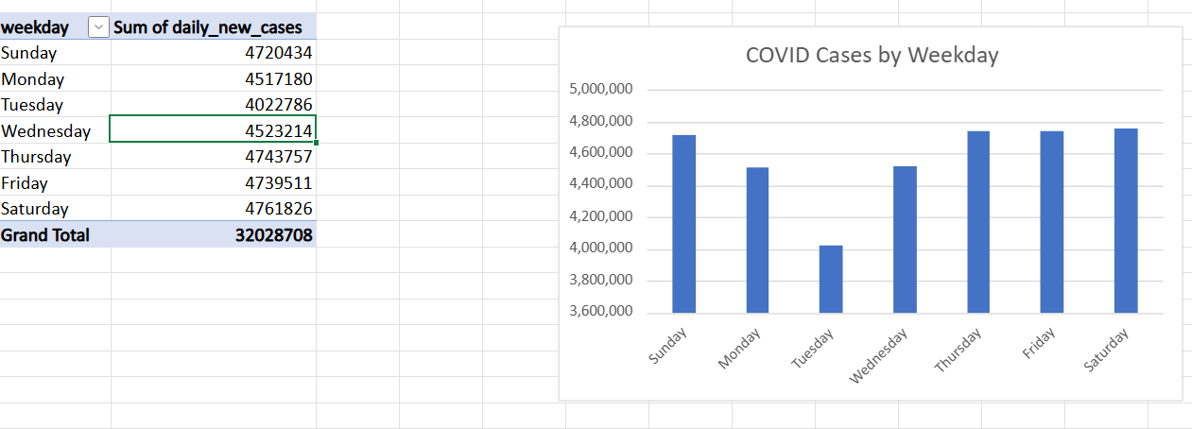

13 Vaccination vs Recovery Rate

🔹 Formula
Recovery Rate = cured / confirmed
Vaccination Rate = doses / population

🔹 Insight
- States with higher vaccination showed better recovery trends

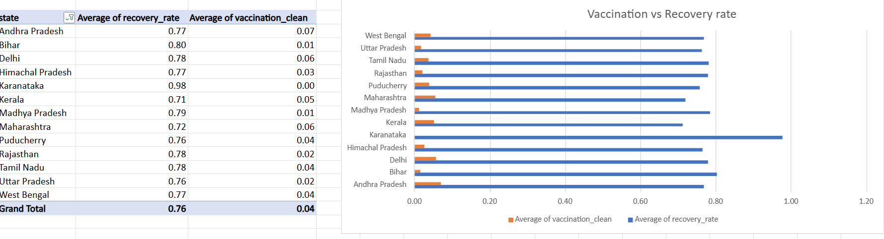

14 Advanced Filtering for Critical States

🔹 Approach
Applied filter:
death_rate > threshold

🔹 Insight
- Identified high-risk states for focused analysis

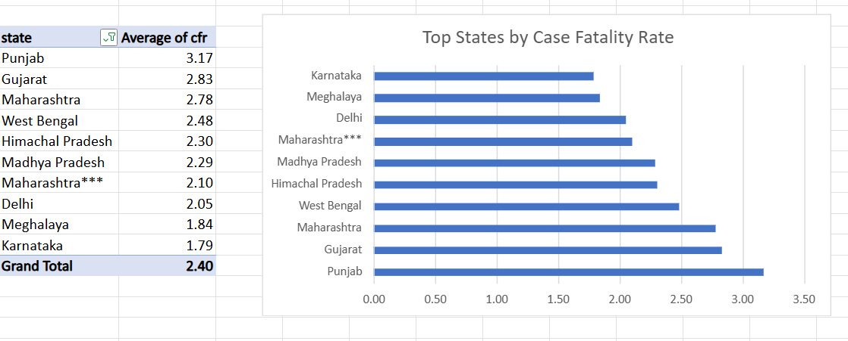

15 Time Series Forecasting

🔹 Approach
Used Excel:
Data → Forecast Sheet
- Input: Date vs Confirmed cases
- Forecast: Next 30 days

🔹 Insight
- Predicted trend aligned with declining case pattern

16 Risk Assessment

🔹 Approach
Used predefined logic:
- High Risk → CFR > 2 AND Positive Rate > 10
- Medium Risk → One condition
- Low Risk → Otherwise

🔹 Insight
- Most states fell under Low/Medium risk
- Few high-risk periods identified

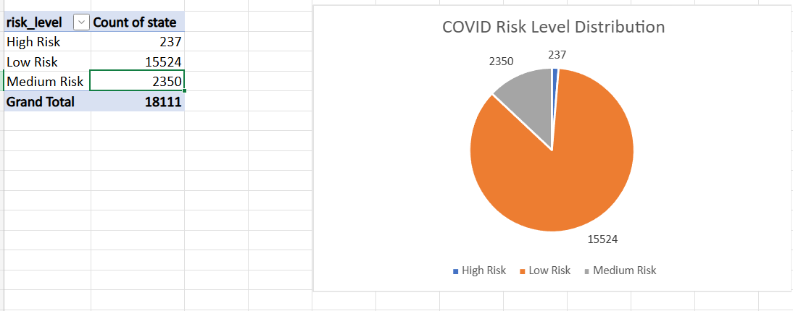

17 Risk Assessment

🔹 Approach
Used predefined logic:
- High Risk → CFR > 2 AND Positive Rate > 10
- Medium Risk → One condition
- Low Risk → Otherwise

🔹 Insight
- Most states fell under Low/Medium risk
- Few high-risk periods identified

18 Date Queries (INDEX + MATCH)
=INDEX(C:C, MATCH(date_value, B:B, 0))

🔹 Use
- Retrieve cases for specific date

19 State-Specific Analysis
=SUMIF(A:A, selected_state, C:C)

🔹 Insight
- Enables dynamic analysis per state

20 Data Validation (Dropdown)

🔹 Steps
- Data → Data Validation
- Source → State column

🔹 Result
- Interactive dashboard filtering
- User can select state dynamically

Visualization Used
- Line Charts → Case trends
- Bar Charts → State comparison
- Pie Charts → Case proportion
- Pivot Tables → Multi-dimensional analysis

The Excel dashboard enabled interactive exploration of COVID-19 trends across states, supporting data-driven insights on infection spread, testing efficiency, and vaccination progress.

FINAL DASHBOARD BELOW:

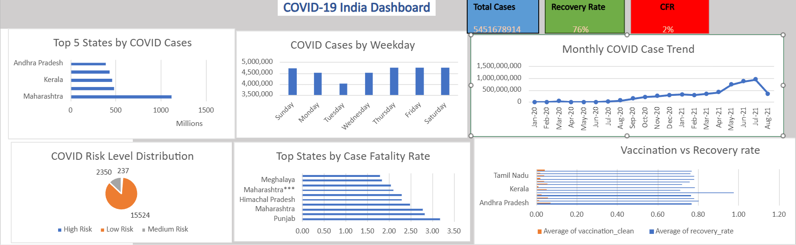

Section 4: Insights & Observations

Uneven Distribution of COVID-19 Cases Across States
The analysis shows that COVID-19 cases were highly concentrated in a few states such as Maharashtra, Karnataka, and Tamil Nadu, which contributed a significant proportion to the national total. In contrast, smaller states and union territories had relatively low case counts. This indicates an uneven spread influenced by population density, urbanization, and mobility patterns.

2 Clear Wave Patterns in COVID-19 Spread
Month-wise trend analysis revealed distinct waves of COVID-19 cases, with sharp increases followed by gradual declines. These peaks align with known pandemic waves in India. The trend highlights how rapidly cases can surge and the importance of timely interventions.

3 Testing and Positive Rate Relationship
States with lower testing volumes showed higher positive test rates, indicating under-testing during certain periods. A high positive rate (>10%) suggests that many cases may have gone undetected. This emphasizes the importance of widespread testing to accurately track the spread of the virus.

4 Vaccination Progress Improved Recovery Trends
The analysis of vaccination and recovery rates indicates that states with higher vaccination coverage generally experienced better recovery outcomes and controlled spread in later phases. Vaccination played a crucial role in reducing severity and improving public health outcomes.

5 Early Data Gaps and Reporting Limitations
Missing values were primarily observed during the early stages of the pandemic, especially in testing and vaccination data. This reflects real-world limitations in data collection and reporting infrastructure during the initial outbreak phase.

Recommended Business Actions

1 Strengthen Testing Infrastructure
Increase testing capacity in regions with high positive rates to ensure early detection and control of outbreaks. Regular monitoring of positive rates can help identify under-tested areas.

2 Target High-Risk Regions with Focused Interventions
States identified as high-risk (based on CFR and positive rate) should receive prioritized healthcare resources, including hospital beds, oxygen supply, and medical staff.

3 Accelerate Vaccination Campaigns
Focus on increasing vaccination coverage in low-performing regions and vulnerable populations to reduce the severity of future outbreaks and improve recovery rates.

4 Improve Data Collection and Reporting Systems
Establish robust data pipelines to minimize missing or inconsistent data, especially during crisis situations. Accurate and timely data is critical for effective decision-making.

5 Use Data-Driven Monitoring and Forecasting
Leverage dashboards and forecasting tools to continuously monitor trends and predict future outbreaks. This will help authorities take proactive measures rather than reactive responses.

CONCLUSION

The analysis demonstrates the importance of integrated data analytics in understanding pandemic dynamics. By combining case, testing, and vaccination data, meaningful insights can be generated to support strategic planning and improve public health response.
DRIVE LINK FOR EXCEL COVID 19:
https://docs.google.com/document/d/1N0r6dyuf3nUnnpVRlUlm1sEVkvC7KZ1TFq6kTV9QnfM/edit?usp=sharing

